## Bollettino Tecnico inglese A.jpgBollettino Tecnico francese B.jpgBollettino Tecnico francese B.jpg

REV. 030014

VITA NET

Acid-based detergent for floors and walls

**FEATURES**

VITA NET is an acid-based, colorless detergent suitable for removing traces of cement and lime after laying floors and walls in ceramic, terracotta, marble, etc., both indoors and outdoors.

**FIELDS OF USE**

VITA NET is indicated for the post-laying cleaning of floors and walls in ceramic, terracotta, marble, etc. Both inside and outside, to eliminate traces of cement or lime from the surfaces.

**PREPARATION OF THE SUPPORT**

Before applying the product, remove all flaking parts and any residual encrustations of adhesives, plasters, etc., with the aid of a wire brush. Then clean the support and let it dry.

**METHOD OF APPLICATION**

Dilute VITA NET with clean water according to the substrate and apply with a brush or sponge. Leave to act for at least 30 minutes and then clean the surfaces until the stains or encrustations are completely removed. Finish the treatment with abundant washes of clean water.

**WARNINGS**

* Apply the product without adding foreign materials.
* Dilute the product according to the substrate only with clean water from 20 to 50%.
* Do not apply in the presence of a threat of rain or rain.
* Do not apply in the presence of the direct sun and strong wind.
* VITA NET must be applied at temperatures between 5 ° C ~ 30 ° C.
* On absorbent surfaces, pay special attention.
* It is advisable to start by cleaning the surfaces starting from the perimeter areas.

.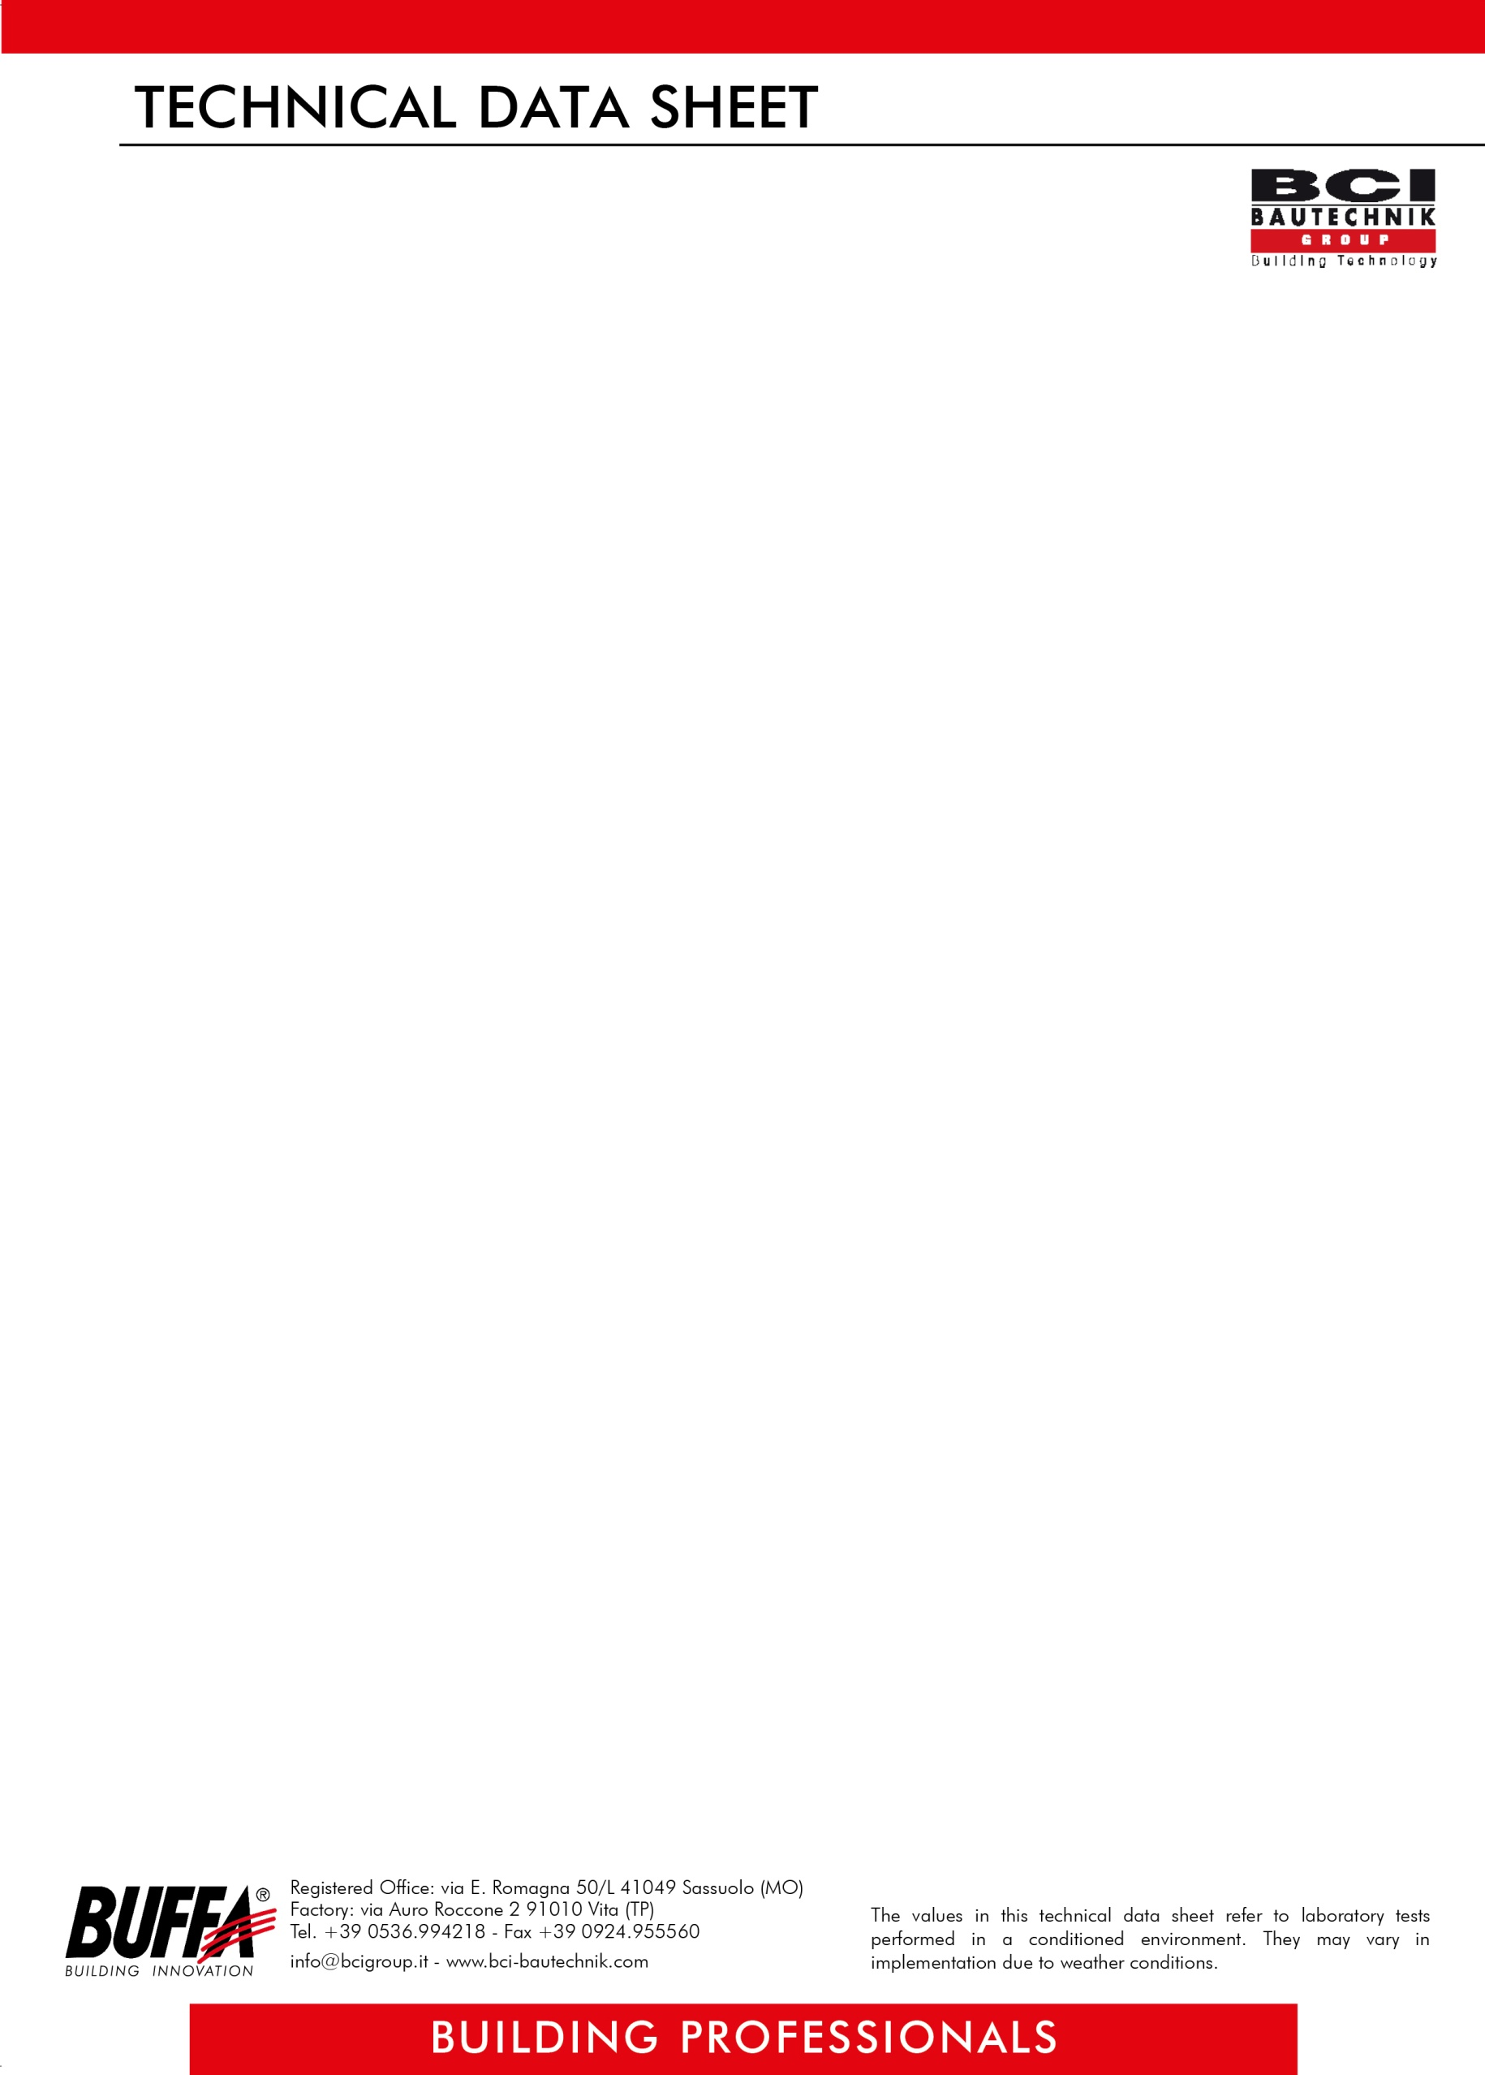

REV. 030014

**ITEM OF SPECIFICATIONS**

Acid-based, colorless detergent, suitable for the post-laying cleaning of floors and walls in ceramic, terracotta, marble, etc., both indoors and outdoors, to eliminate traces of cement or lime from surfaces, from applying with a brush or sponge, to be diluted with clean water from 20 to 50% depending on the substrate, with consumption depending on use, such as **VITA NET *BUFFA***.

**TECHNICAL DATA**

|  |
| --- |
| **DILUTION** with clean water from 20 to 50% depending on the substrate |
| **COMPOSITION** inorganic acids |
| **SPECIFIC WEIGHT** 1003 ± 0.010 g / lt |
| **VISCOSITY** 20 cps at 20 ° C |
| **COLOR** colorless |
| **YIELD** depending on use |
| **PACKAGING**  1 x 12 lt or 5 x 4 lt boxes, 25 lt cans |
| **STORAGE** -12 months, in intact packaging away from sources of frost, heat and humidity) |
| **TOXICITY** as it is an acid product, avoid contact with metal and marble surfaces that are not resistant to acids. Use gloves, rubber boots and protective goggles. If the product comes into contact with the skin, wash with soap and water and rinse thoroughly |

***ATTENTION***

*The above information, prescriptions, and indications result from our best technical and applicative knowledge; nevertheless, they are considered purely indicative. Therefore, it is the responsibility of the user to verify, assuming full responsibility, the compatibility of the products with the intended use, as we can't intervene directly on the conditions of the construction sites and on the methods of carrying out the work. In this regard, a preventive test is recommended to verify the product's suitability for its intended use.*