## Bollettino Tecnico inglese A.jpgBollettino Tecnico francese B.jpgBollettino Tecnico francese B.jpg

REV. 209021

MAX ETIL

Strong penetrating protective consolidator

**FEATURES**

**MAX ETIL** is a ready-to-use, white-colored, highly breathable, highly penetrating protective consolidator based on modified silicates, designed to consolidate crumbling surfaces in absorbent substrates such as plasters, mineral coatings, tuff, etc.

**FIELDS OF USE**

**MAX ETIL** is indicated for consolidating crumbling surfaces in absorbent substrates such as plasters, mineral coatings, tuff, etc., as part of specific restoration cycles, both indoors and outdoors.

**PREPARATION OF THE SUPPORT**

Before applying **MAX ETIL**, make sure that the substrate is dry, clean, and free from dust, oils and greases, paints, flaking parts, and layers of separating substances.

**METHOD OF APPLICATION**

In the case of substrates that will not remain visible after treatment, apply **MAX ETIL** with a brush, roller, or spray to one or more coats depending on the substrate, taking care to spread the product sufficiently and uniformly, avoiding dripping; between one coat and the other, allow at least 6-8 hours to pass. In the case of substrates that will remain exposed, apply a coat of **MAX ETIL** with a brush, roller, or spray.

**WARNINGS**

* As the product is ready for use, apply as it is, without adding foreign materials.
* Do not apply in the presence of direct sunlight, strong wind, the threat of rain or rain.
* Avoid applying below 5 ° C and above 30 ° C
* It is advisable to conduct a preliminary test with **MAX ETIL** to verify its effectiveness and any aesthetic effect; excessive use of the product could cause drains and/or traces or whitish spots on the surfaces.
* It is recommended to use skilled labor.
* Do not apply the product in excessive quantities to avoid draining.

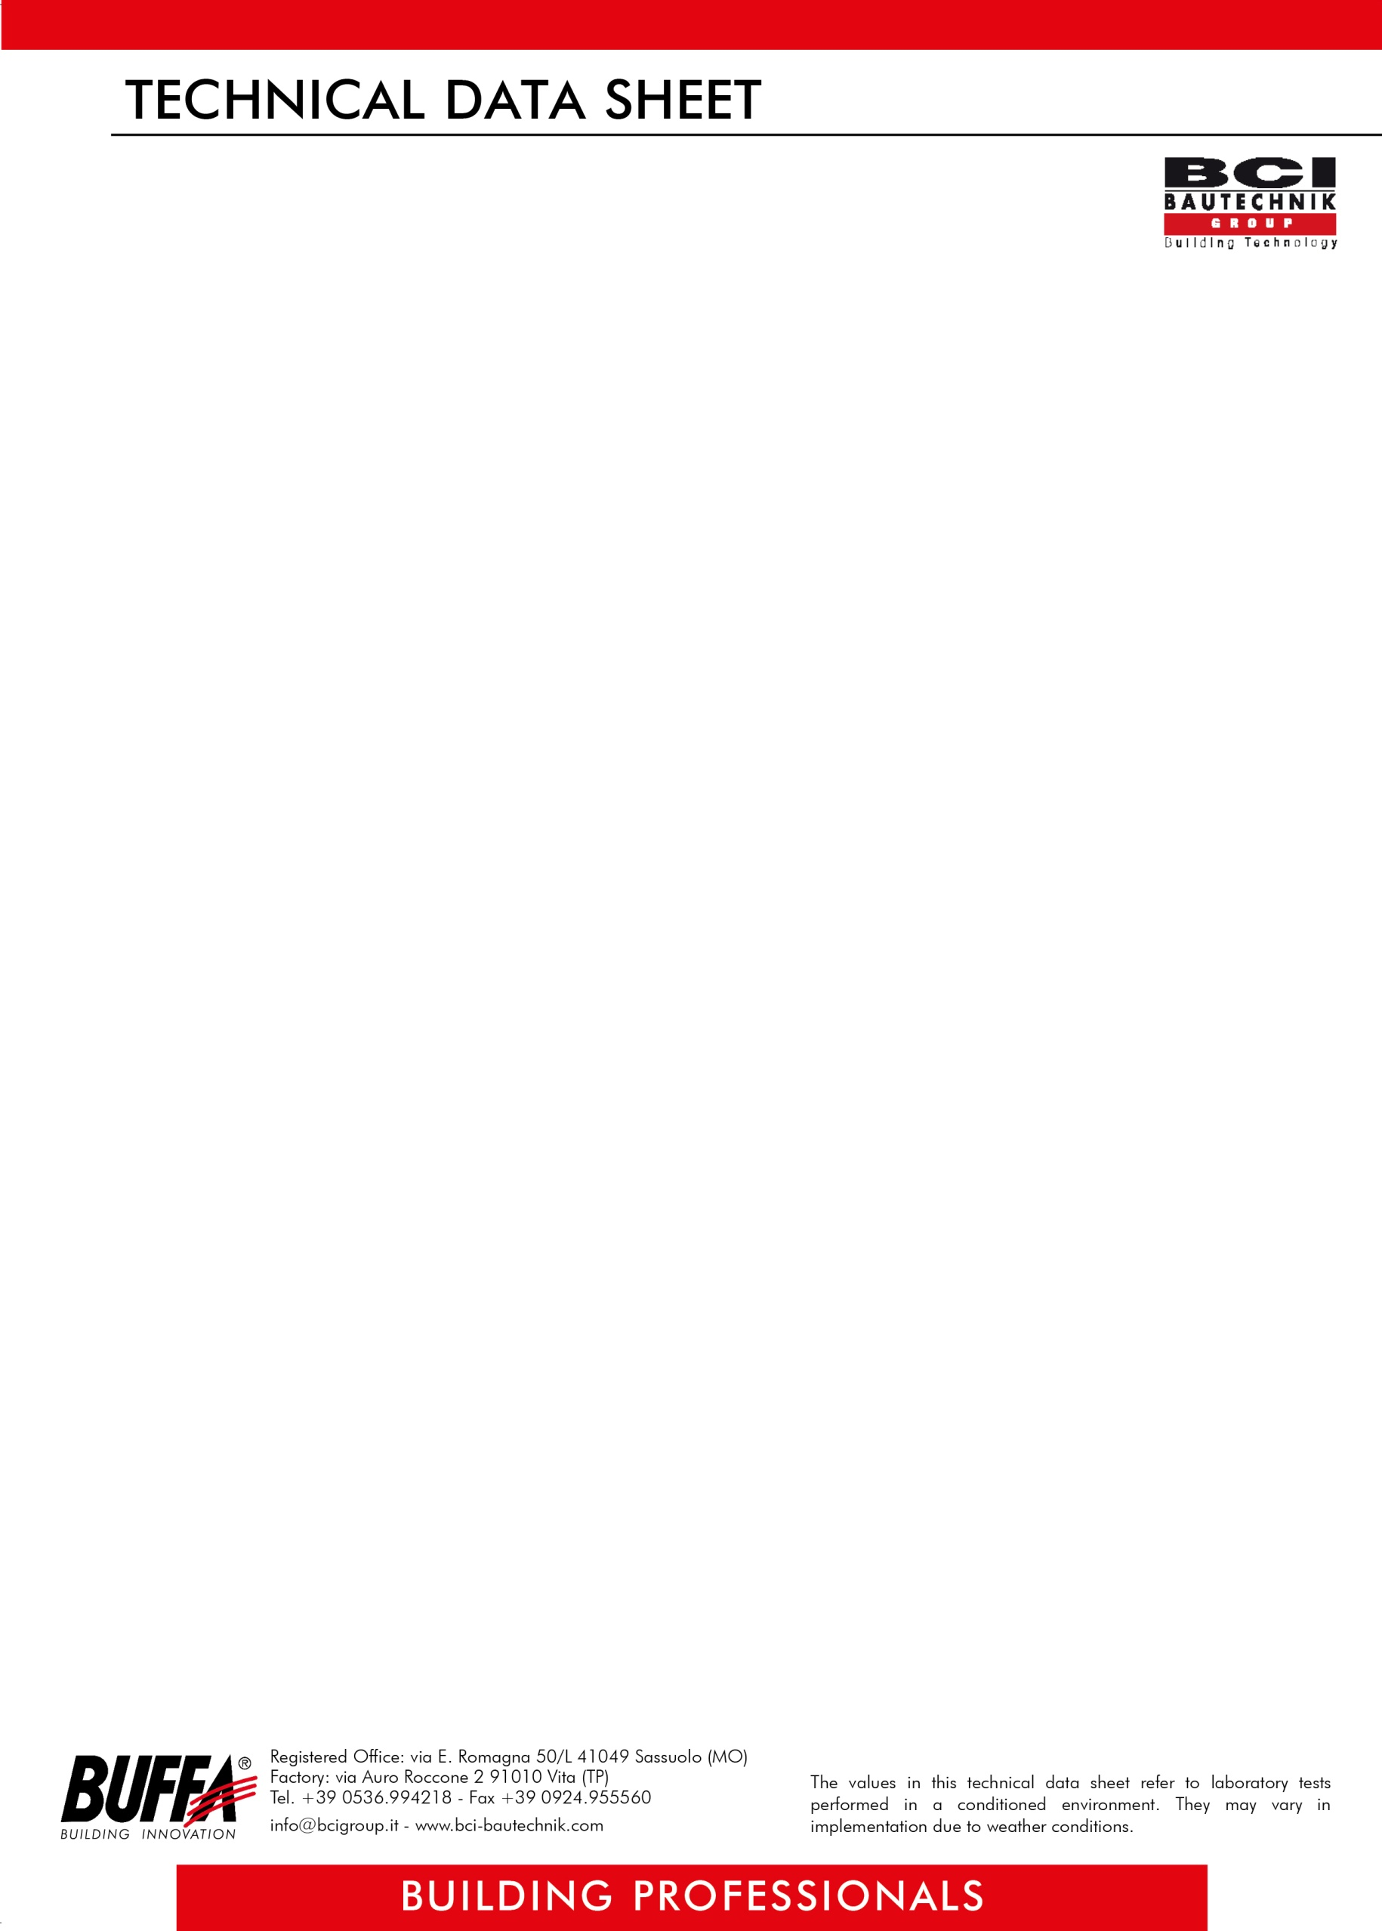

REV. 209021

**ITEM OF SPECIFICATIONS**

Ready-to-use, highly-penetrating protective consolidator, white in color, with high breathability, based on modified silicates, designed for the consolidation of crumbling surfaces in absorbent substrates such as plasters, mineral coatings, etc., in the context of specific cycles for restoration, both inside and outside, to be applied with a brush, roller or spray to one or more coats in the case of substrates that will not remain visible and with a single coat in the case of exposed substrates, with consumption of 0,15 / 0,25 liters per m² per coat, such as **MAX ETIL *BUFFA*.**

.

**TECHNICAL DATA**

|  |
| --- |
| **DILUITION**  ready for use |
| **COMPOSITION** a solution based on modified silicates |
| **DRYING** about 6-8 hours |
| **YIELD** 0,15 / 0,25 lt per m² per coat |
| **COLOR** white |
| **PACKAGING** boxes of lt 1x12 or lt 5x4, tanks of 25 lt |
| **STORAGE** semi-fluid |
| **PH** 11,50 |
| **POT LIFE** 30 - 40 minutes |
| **TRANSITABLE** 10 hours |
| **HARDENING** 14 days |
| **PACKAGING** 5 x 4 kg boxes; 25 kg bags |
| **YIELD** see consumption table |
| **STORAGE** 12 months, in unopened packages away from sources of frost, heat, and humidity |
| **TOXICITY** ventilate the rooms where it is applied. Use protective gloves and goggles. If the product comes into contact with the skin, wash with soap and water and rinse thoroughly. |

***ATTENTION***

*The above information, prescriptions, and indications result from our best technical and applicative knowledge; nevertheless, they are considered purely indicative. Therefore, it is the responsibility of the user to verify, assuming full responsibility, the compatibility of the products with the intended use, as we can't intervene directly on the conditions of the construction sites and on the methods of carrying out the work. In this regard, a preventive test is recommended to verify the product's suitability for its intended use*.

.