## Bollettino Tecnico inglese A.jpgBollettino Tecnico francese B.jpgBollettino Tecnico francese B.jpg

REV. 038020

TOP ELAST FIBRO

Ready-to-paste, fiber-reinforced, waterproof, elastomeric acrylic skimming plaster

**FEATURES**

**TOP ELAST FIBRO** is an elastomeric, waterproof, fiber-reinforced acrylic smoothing compound, ready in paste, gray in color, filler, ideal for waterproofing bathrooms, showers, and kitchens, even on plasterboard, pitched roofs, balconies, terraces, exposed walls, etc.

**FIELDS OF USE**

**TOP ELAST FIBRO** allows waterproofing of bathrooms, showers, and kitchens, even on plasterboard, and, thanks to the rough finish, it favors an excellent bond to specific adhesives for laying ceramic, porcelain stoneware, glass mosaic, marble, etc. It can also be applied on ceramic substrates after applying the ***PROMO MAX*** water adhesion promoter.

It is also suitable for waterproofing external walls exposed to bad weather and/or cracks, pitched roofs, terraces, and balconies. It also guarantees an excellent coupling to the mortar for laying the tiles.

Given its strong gripping power, it also sticks to wood, metal, polystyrene, etc.

For indoors and outdoors

**PREPARATION OF THE SUPPORT**

The surface to be treated must be perfectly dry, clean, and solid. Dust, traces of oils and greases, flaking parts, and layers of separating substances must be eliminated from the substrate. On old or very absorbent substrates, it is advisable to first apply one of our ***VIDUEST*** primers, ***PRIMER PA***, ***PROMO* *MAX***, or ***FONDO VITA***, depending on the substrate. On smooth supports or pads, we recommend the use of ***PROMO MAX***or***PROMO PLUS***.

**METHOD OF APPLICATION**

Mix the product well before application.

Apply **TOP ELAST FIBRO** in two coats with a smooth stainless steel trowel, horizontally and vertically, allowing at least 24 hours to pass between one and the other.

It can be reinforced with ***RETE PB***or***RETE PB EXTRA*** in pre-primed glass fiber, taking care to drown it in the first fresh coat of **TOP ELAST FIBRO**. To ensure total continuity and waterproofing of the system, it is necessary, before applying the **TOP ELAST FIBRO**, to apply the ***GIUNTO BOND*** (waterproof and elastic band) with the relative accessories ***ANGOLARE B10*** and ***ANGOLARE B11*** on the corners between floor and wall, and of the ***GIUNTO BOND***only in correspondence with any expansion joints.

For floor waterproofing left exposed without subsequent tiling, apply our elastic U.V. protective sheath to **TOP ELAST FIBRO**. ***COPER PROTECTOR***. For waterproofing and protection of external walls, protect the **TOP ELAST FIBRO** with ***ELASTO PAINT FIBRO***.

**WARNINGS**

* Do not apply **TOP ELAST FIBRO** in thicknesses greater than 2 mm per coat.
* Do not apply on damp surfaces or surfaces subject to stagnation of water.
* Avoid applying below 5 ° C and above 35 ° C.
* Do not apply with the threat of rain, rain, direct sun, or strong wind.
* Protect from rain or accidental water in the first 24 hours after installation, ensuring that the temperature never drops to zero degrees.
* Use **TOP ELAST FIBRO** without adding foreign materials or water.
* Protect from frost.

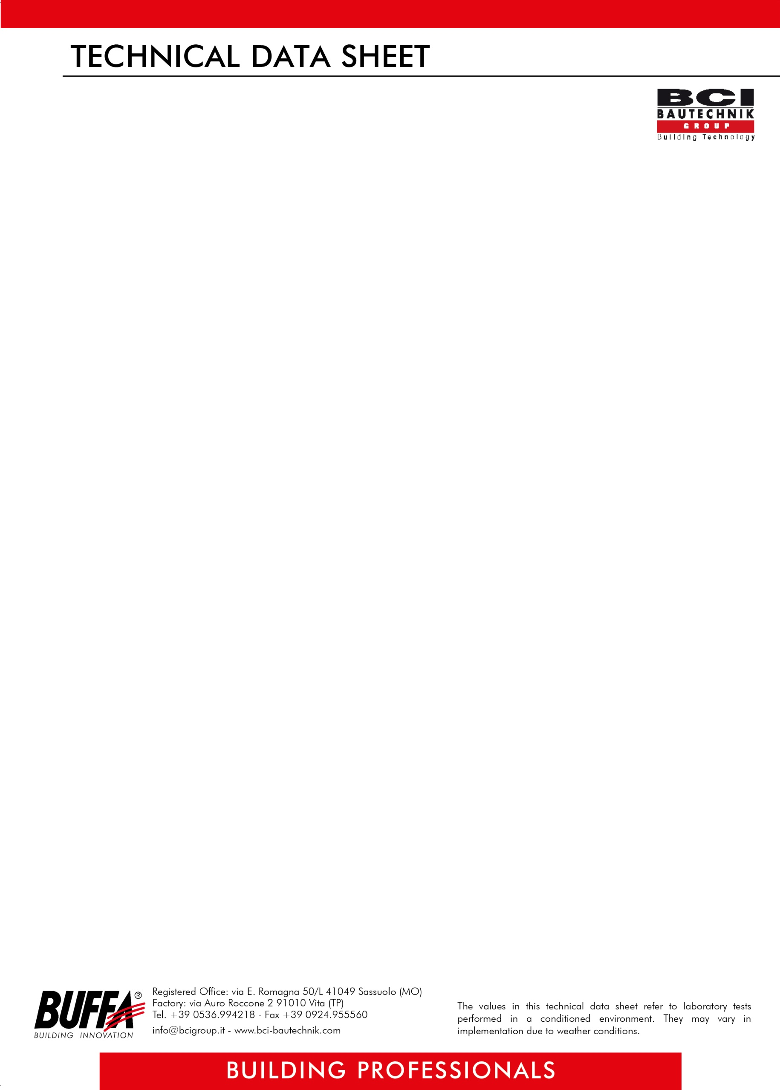

REV. 038020

**ITEM OF SPECIFICATIONS**

Elastomeric acrylic skim coat, waterproof, fiber-reinforced, ready in paste, gray color, filler, ideal for waterproofing bathrooms, showers and kitchens, also on plasterboard, external walls exposed to the elements, pitched roofs, terraces, and balconies, allowing, thanks to its rough finish, an excellent coupling to specific adhesives for laying ceramic, porcelain stoneware, glass mosaic, marble, etc., also suitable for wood, metal, polystyrene, etc., to be applied with a smooth stainless steel trowel, having a consumption on cross-section without reinforcement mesh of 1,2 / 1,5 kg per m² (first coat) and 0,7 / 0,9 kg per m² (second coat), and 2,4 / 2,7 kg per m² for two coats if reinforced with mesh, such as **TOP ELAST FIBRO *BUFFA***.

**TECHNICAL DATA**

|  |
| --- |
| **APPEARANCE** paste |
| **COLOR** Grey |
| **PACKAGING** boxes of 6 kg for 4; 20kg buckets |
| **STORAGE** 18 months if stored in intact packaging away from frost, humidity, and heat sources. |
| **YIELD** 1,2 / 1,5 kg per m² (first coat) and 0,7 / 0,9 kg per m2  (second coat) on the beam without reinforcement mesh; ……………………………………………………………………….2,4 / 2,7 kg per m2 for two coats on a beam with ……………………………………………………………………….reinforcement mesh |
| **MIXTURE RATIO** ready for use |
| **CONSISTENCY** plastic |
| **MIXTURE** pH 9 |
| **MIXTURE SPECIFIC WEIGHT** 1,6 g / cm³ |
| **APPLICATION TEMPERATURE** From + 5 ° C to + 35 ° C |

***ATTENTION***

*The above information, prescriptions, and indications result from our best technical and applicative knowledge; nevertheless, they are considered purely indicative. Therefore, it is the responsibility of the user to verify, assuming full responsibility, the compatibility of the products with the intended use, as we can't intervene directly on the conditions of the construction sites and on the methods of carrying out the work. In this regard, a preventive test is recommended to verify the product's suitability for its intended use.*