## Bollettino Tecnico inglese A.jpgBollettino Tecnico francese B.jpgBollettino Tecnico francese B.jpg

REV. 014020

KOBOSS

Pre-blended microporous dehumidifying anti-salt fiber-reinforced coarse-grained skimming plaster

**FEATURES**

**KOBOSS** is a premixed microporous, dehumidifying, anti-salt, fiber-reinforced, transpiring, pearl gray, coarse-grained skimming plaster, studied in the context of specific low-thickness remediation cycles against rising dampness without the need to demolish, for masonry and concrete. For indoors and outdoors.

**FIELDS OF USE**

**KOBOSS** is applied in low thickness on cohesive, rough, compact, and dried cementitious plasters, after abrasion of only the damaged surface parts, preferably using a special wall milling machine or a suitable trowel or scraper.

It is also suitable on concrete substrates and fiber-reinforced mortars such as***MALTA HL 100***.

**PREPARATION OF THE SUPPORT**

By mechanical or manual abrasion, proceed with the total removal of efflorescence, paint, finishing plaster, and/or deteriorated skimming plaster. Carry out the treatment mentioned above up to a depth of about 5-7 mm, extending in height up to about one meter beyond the last traces of humidity, preferably using a special wall milling machine.

Then proceed with a dry cleaning of the surfaces using special brushes. Then moisten the support.

Typically it would not help to get the walls completely bare; however, in the presence of very degraded supports without cohesion, it is necessary to clean thoroughly until suitable supports for anchoring are reached.

Where necessary, demolish the plaster limited to the areas mentioned above and subsequently restore with ***MALTA HL 100*** in thickness (respect the relative drying times) before applying, after cleaning the substrates, the***RINZAFFO LIBECCIO ANTISALE*** or ***MALTA RINZAFFO ANTISALE***.

If, on the other hand, the pre-existing plasters, although cohesive and solid, have slightly crumbling surfaces, proceed with the application of the consolidating agent ***MAX ETIL*** or ***MAX ETIL PLUS***.

**METHOD OF APPLICATION**

For mixing with a low-speed electric stirrer, add approximately 5 liters of clean water to each 25 kg bag of **KOBOSS**. The mixing time should not exceed 5 minutes.

Then spread the **KOBOSS** to level with a smooth stainless steel trowel, applying it in two coats, spaced at least 12-24 hours apart, taking care to drown the ***RETE PB*** or the ***RETE PB EXTRA*** in the first coat of **KOBOSS** when fresh, until a total thickness of not less than 5-6 mm is reached, reaching the level of the healthy part above.

After at least 48 hours, complete the application cycle with ***RASANTE LIBECCIO PLUS****,* ***RASOX PLUS M****,* ***RASOX PLUS F****,* ***RASOX STAR MEDIO****,* ***RASOX STAR FINE****,* ***MINERAL K MAX****,* etc., with one or two coats.

Inside, if a smooth surface is desired, applying two coats of ***STUCCO COC NX*** to the appropriate leveling compound, spaced approximately 30-60 minutes apart, is advisable. If you wish to paint, use only transpiring paints such as ***CALCITE FIORE****,* ***CALCITE FIORE EXTRA****,* ***RISANAVITA AI SILICATI****,* ***RISANAVITA AI SILOSSANI****,* etc., after the use of specific funds and/or primers. Outside, always with a special smoothing layer, it is advisable to close the system with transpiring thickness finishes with silicates or siloxanes, such as ***RISANAVITA AI SILICATI F-M-G****,* ***RISANAVITA AI SILICATI CF-CM****,* ***RISANAVITA AI SILOSSANI F-M-G****,* ***RISANAVITA AI SILOSSANI CF -CM****,* etc.

**WARNINGS**

* KOBOSS must be used as it is without adding foreign materials.
* Use with temperatures between 5 ° and 30 ° C.
* It is necessary to protect from sun exposure and strong wind.
* Store KOBOSS in unopened packages away from moisture.
* Do not apply on gypsum.
* It is recommended to use skilled labor.

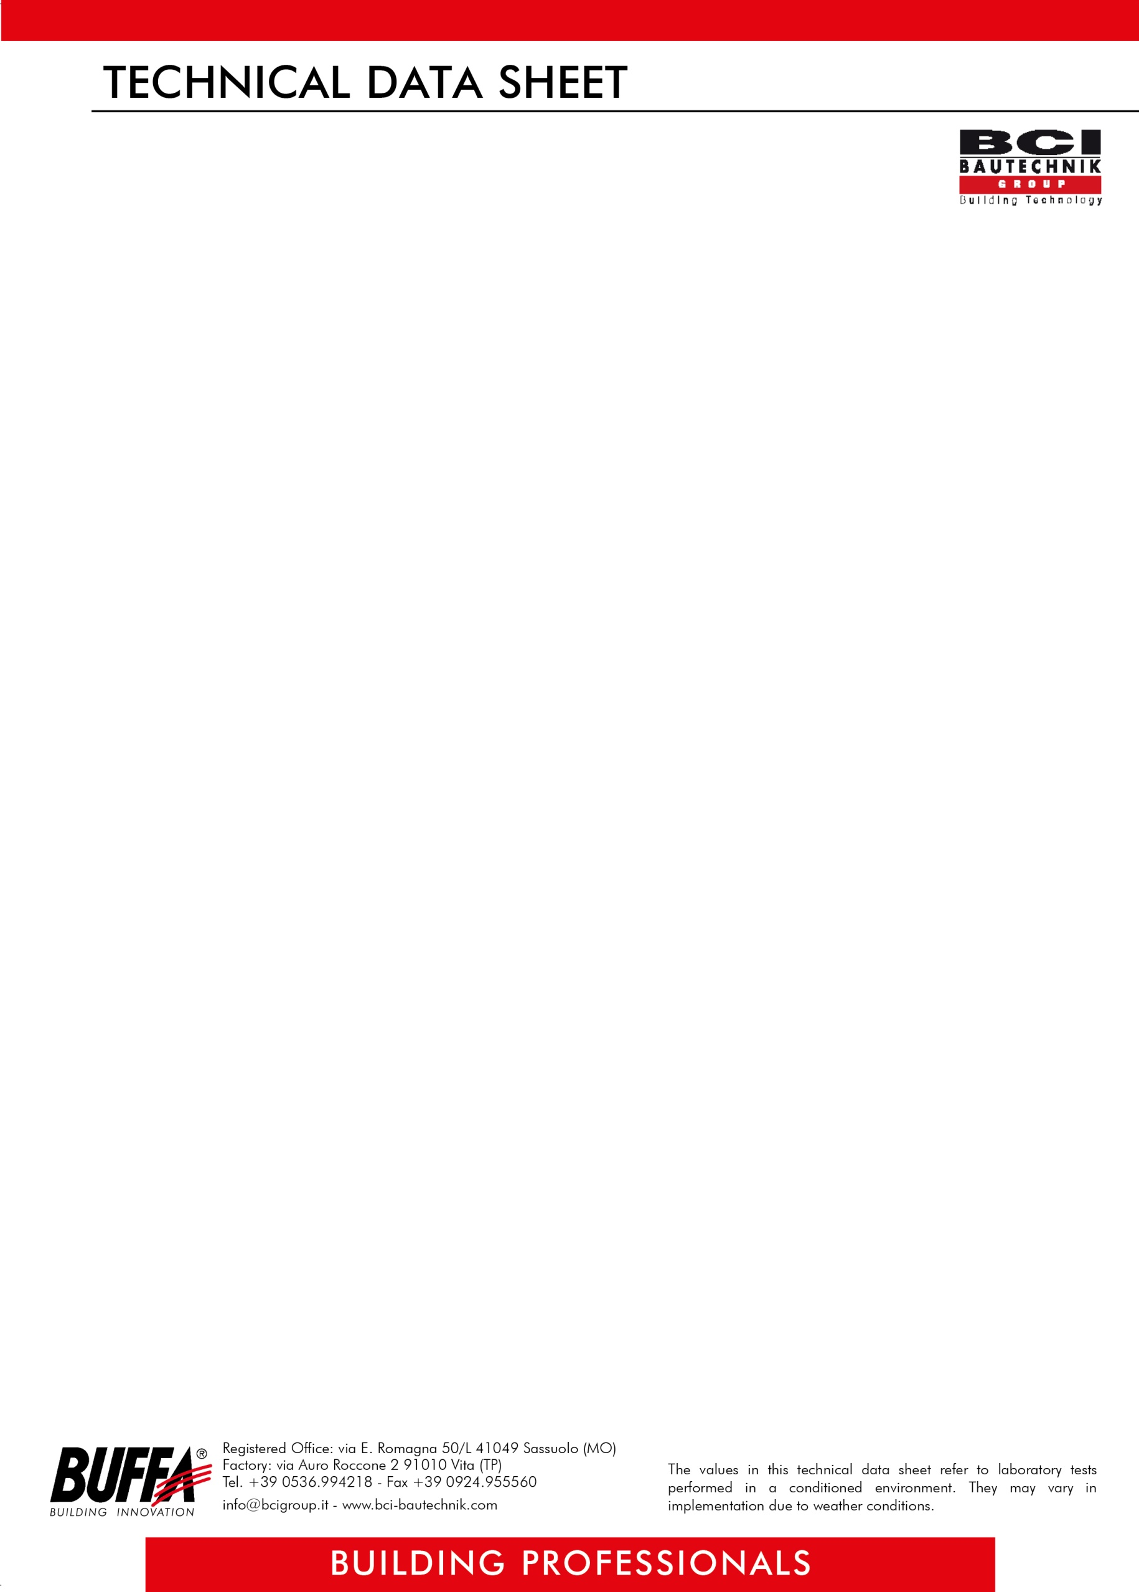

REV. 014020

**ITEM OF SPECIFICATIONS**

Application of premixed microporous, dehumidifying, anti-salt, fiber-reinforced, transpiring, pearl gray, coarse-grained skimming plaster, studied in the context of specific low thickness restoration cycles against rising dampness without the need to demolish for masonry and concrete, based on cement, selected aggregates, specific additives, and synthetic fibers, for interiors and exteriors, to be applied in two coats, spaced at least 12-24 hours apart, taking care to drown in the first coat when fresh the ***RETE PB BUFFA*** or ***RETE PB EXTRA BUFFA***, until a total thickness of not less than 5-6 mm is reached, having consumption of 6/7 kg per m² for two coats, such as **KOBOSS *BUFFA***.

**TECHNICAL DATA**

|  |
| --- |
| **COMPOSITION** - Portland cement 52,5  - selected aggregates  - specific additives  - synthetic fibers |
| **COLOR** Pearl gray |
| **MIXING WATER** Approximately 20% |
| **GRANULOMETRY** max 3.0 mm |
| **COMPRESSION RESISTANCE** CSIII |
| **WATER VAPOR PERMEABILITY** µ = 15/35 |
| **THERMAL CONDUCTIVITY** λ = 0.75 W / m K (Average value of prospectus P = 50%) |
| **ADHESION** 0,7 N / mm² - FP: B |
| **WATER ABSORPTION** class W2 |
| **YIELD** 6/7 kg per m² for two coats (for a total thickness of approx. 5 mm) |
| **PACKAGING** 25 kg bags |
| **STORAGE** 6 months in unopened packages away from heat, frost, and humidity |
| **SAFETY** see safety data sheet |

Compliant with UNI EN 998-1: 2010 - class GP - CS III - W 2

***ATTENTION***

*The above information, prescriptions, and indications result from our best technical and applicative knowledge; nevertheless, they are considered purely indicative. Therefore, it is the responsibility of the user to verify, assuming full responsibility, the compatibility of the products with the intended use, as we can't intervene directly on the conditions of the construction sites and on the methods of carrying out the work. In this regard, a preventive test is recommended to verify the product's suitability for its intended use*.

.