## Bollettino Tecnico inglese A.jpgBollettino Tecnico francese B.jpgBollettino Tecnico francese B.jpg

REV. 259021

COPER CEM FLEX 2C

Two-component cementitious sheath of superior technology

**FEATURES**

**COPER CEM FLEX 2C** is a two-component, high-tech, high-strength, flexible, gray-colored, fiber-reinforced cementitious sheath based on cement, selected aggregates, and synthetic polymers in aqueous dispersion. By mixing only the two components A (powder) and B (liquid), a flexible, trowelable, highly resistant mixture is obtained, which can also be applied vertically up to 1 - 2 mm thick in a single coat.

Once hardened, **COPER CEM FLEX 2C** becomes an elastic sheath, very resistant and waterproof, on which it is possible to apply suitable adhesives such as ***DURAFLEX*** or ***DURAFLEX IMPER*** directly on top for subsequent flooring or our special elastic and waterproof white or colored such as ***COPER PAINT****,* ***COPER PAINT PLUS****,* ***COPER PAINT FINISH AS****,* ***COPER THERM****,* ***COPER GUM****,* ***ANCORANTE BH****,* etc. for its UV protection if the sheath remains visible.

**COPER CEM FLEX 2C** is provided with the following packages: 4 kg (3 kg component A + 1 lt component B), 16 kg (12 kg component A + 4 lt component B) and 32 kg (24 kg component A + 8 lt component B).

**FIELDS OF USE**

**COPER CEM FLEX 2C** is a sheath suitable for the protection and waterproofing of flat or pitched roofs, terraces, balconies, showers, water basins and concrete pools, foundations, etc., with perfect adhesion even on ceramic.

**PREPARATION OF THE SUPPORT**

The surfaces to be waterproofed with **COPER CEM FLEX 2C** must be perfectly dry, clean, and solid. Traces of dust, oils, greases, release agents, flaking parts, or layers of separating substances must be eliminated from the substrate. Moisten the substrate with water, if absorbent, only if necessary.

In case of application on non-absorbent substrates such as klinker stoneware tiles, etc., it is advisable to first apply a layer of ***MALTA OSMOTICA 2C*** as an adhesion base for the sheath.

**METHOD OF APPLICATION**

Pour component B (liquid) into a suitable clean container; then add, slowly and mechanically, component A (powder), mixing carefully for a few minutes with a low-speed mixer, until a smooth and homogeneous mixture is obtained; **COPER CEM FLEX 2C** must be applied within 40 minutes of mixing.

Spread the mortar thus obtained on the substrate with a smooth stainless steel spatula or a special doctor blade (spreading blade) with a maximum thickness, per layer, of about 1 ~ 2 mm. In the first fresh layer of **COPER CEM FLEX 2C**, it is advisable to drown the ***RETE PB*** in glass fiber, alkali resistant and already primed, as reinforcement. The edges of the ***RETE* *PB*** (in rolls) must overlap by at least 5 cm.

Then apply the second coat when the first is completely dry. To ensure total continuity and waterproofing of the system, before applying **COPER CEM FLEX 2C**, it is necessary to apply

***GIUNTO BOND*** (waterproof and elastic band) with the relative ***ANGOLARE B10***accessories (internal waterproof corner) and ***ANGOLARE B11*** (external waterproof corner) on the corners between floor and wall, and of the ***GIUNTO BOND*** only in correspondence with any expansion joints.

For the subsequent laying of ceramic such as stoneware, etc., after at least 5 days of drying the sheath, it is recommended to use our ***DURAFLEX*** adhesive and our ***COLORFILL 2 ~ 12*** or ***PAVIFILL 4 ~ 20*** joint sealants directly on the **COPER CEM FLEX 2C**. Better if mixed with our ***FILL PLUS*** elastomeric latex for joints.

For unpaved surfaces, on the other hand, we recommend the application of our special elastic and waterproof sheaths ***COPER PAINT****,* ***COPER PAINT PLUS****,* ***COPER PAINT FINISH AS****,* ***COPER THERM****,* ***COPER GUM****,* ***ANCORANTE BH****,* etc. for UV protection of **COPER CEM FLEX 2C** left exposed.

**WARNINGS**

* For interventions on new substrates, prepare the screed with appropriate slopes to avoid water stagnation; for interventions on existing supports, check the slopes before applying COPER CEM FLEX 2C.
* Avoid applying below 5 ° C and above 35 ° C.
* Do not apply COPER CEM FLEX 2C in thicknesses greater than 2 mm per coat.
* Do not add other aggregates or hydraulic binders to the COPER CEM FLEX 2C.
* Always respect the correct mixing ratio.
* Do not apply with the threat of rain, rain, direct sun, or strong wind.
* Protect from rain or accidental water in the first 24 hours of installation, also making sure that the temperature never drops to zero degrees.
* For terraces or coverings of large surfaces, provide suitable expansion joints and also steam vents, located according to the humidity present in the substrate (approximately every 25/30 m²). This last warning is essential when COPER CEM FLEX 2C is applied on particularly absorbent substrates that retain moisture, such as lightened screeds.
* For large pools, thick stone coverings are not recommended.

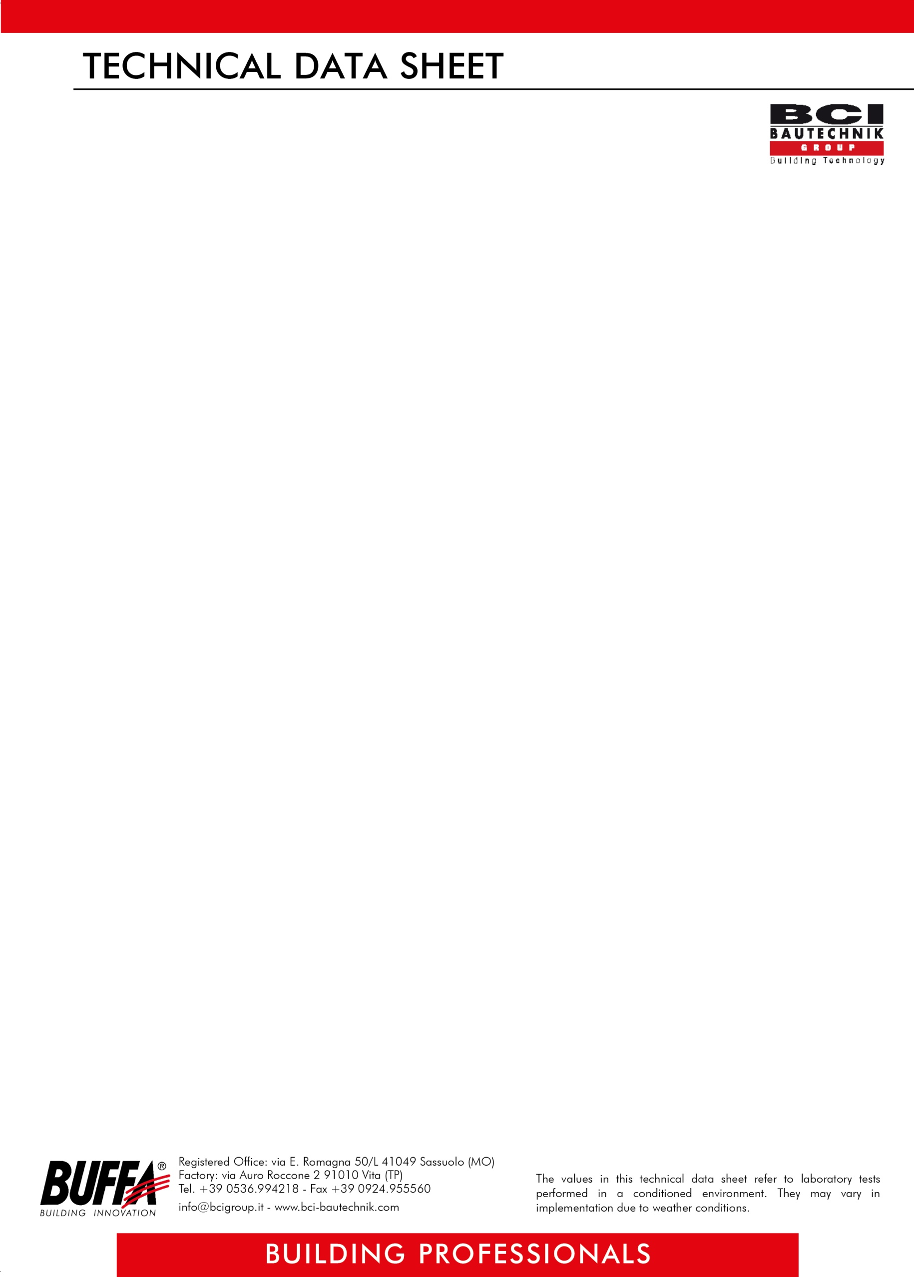

REV. 259021

**ITEM OF SPECIFICATIONS**

Application of two-component, high-tech, fiber-reinforced, high-strength, and flexible cementitious sheath, based on cement, selected aggregates and synthetic polymers in water dispersion, gray in color, suitable for waterproofing flat or pitched roofs, terraces, balconies, concrete showers, water basins and swimming pools, foundations, etc., obtainable by mixing only components A (powder) and B (liquid), to be applied in two coats with a smooth stainless steel trowel, after applying the elastic and waterproof accessories ***GIUNTO BOND BUFFA*** (strip) and***ANGOLARE B10* *BUFFA*** and ***ANGOLARE B11 BUFFA***, preferably by drowning ***RETE PB* *BUFFA*** in glass fiber in the first coat, with an average consumption of 1,5 kg per m² per mm of thickness, to be paved directly above with suitable adhesives such as ***DURAFLEX BUFFA*** or UV protection with elastic sheaths such as ***COPER PAINT BUFFA****,* ***COPER PAINT PLUS BUFFA****,* ***COPER PAINT FINISH AS BUFFA****,* ***COPER THERM BUFFA****,* ***COPER GUM BUFFA****,* ***ANCORANTE BH BUFFA****,* etc., if left exposed, such as **COPER CEM FLEX 2C *BUFFA***.

**TECHNICAL DATA COMP.A**

|  |
| --- |
| **APPEARANCE** powder |
| **COLOR** Grey |
| **APPARENT DENSITY** 1,4 g / cm³ |
| **SOLID RESIDUE** 100% |
| **TOXICITY** non-toxic product |
| **PACKAGING** 3/12/24 kg bags |
| **STORAGE** 12 months in unopened packages, away from sources of heat, frost, and humidity |
| **PACKAGING** 1 kg bags |

**TECHNICAL DATA COMP.B**

|  |
| --- |
| **APPEARANCE** liquid |
| **COLOR** White |
| **APPARENT DENSITY** 1,1 g / cm³ |
| **pH (IN WATER DISPERSION, 10%)** 7,5 at 25 ° C |
| **SOLID RESIDUE** 50% |
| **TOXICITY** non-toxic product |
| **PACKAGING** 1/4/8 lt cans |
| **STORAGE** 12 months in unopened packages, away from sources of heat, frost, and humidity |
| **PACKAGING** 1 kg bags |

**APPLICATION DATA**

|  |
| --- |
| **YIELD** 1,5 Kg per m² per mm of thickness |
| **MIXTURE RATIO** Comp. A: Comp. B = 3: 1 |
| **CONSISTENCY OF THE MIX** plastic - trowelable |
| **pH OF THE MIX** 12,8 |
| **MASS DENSITY OF THE MIX** 1,6 g / cm³ |
| **APPLICATION TEMPERATURE** from + 5 ° C to + 35 ° C |
| **MIX DURATION** 40 min |

**FINAL PERFORMANCE**

|  |
| --- |
| **DIRECT TRACTION ADHESION TEST (UNI EN 1504-2: 2005)** ≥ 1 N / mm² |
| **CRACK BRIDGING ability + 23 ° C (UNI EN 14891- A.8.2)** ≥ 0,75 mm |
| **CRACK BRIDGING ability - 20 ° C (UNI EN 14891- A.8.3)** ≥ 0,75 mm |

***ATTENTION***

*The above information, prescriptions, and indications result from our best technical and applicative knowledge; nevertheless, they are considered purely indicative. Therefore, it is the responsibility of the user to verify, assuming full responsibility, the compatibility of the products with the intended use, as we can't intervene directly on the conditions of the construction sites and on the methods of carrying out the work. In this regard, a preventive test is recommended to verify the product's suitability for its intended use*.

.